OVERALL PROGRAMME EVALUATION REPORT
Social Entrepreneurship Program (SEP)- Growth MASTERCLASS Module 1 Kenya (2nd March 2026 - 6th March 2026)
No. of Respondents: 13
No. of Participants: 95
Response Rate: 14%
--------------------------------------------------

Faculty Reports

Loise Wanjiru Oburu - Business Plan reviews
Evaluation Parameter | (%) Individual Score | (%) Programme Average
Punctuality (Commencement and Completion of Sessions) | 96 | 93
How well do you understand the core concepts presented? | 100 | 95
Rate your confidence in applying the new skills learnt | 88 | 88
Degree of Faculty preparedness for the sessions | 100 | 95
Content and methodology of the program | 100 | 96
Quality of class and group discussions | 96 | 89
The information presented in the course is relevant to my work (ministry) | 100 | 97
Average scores | 97 | 93

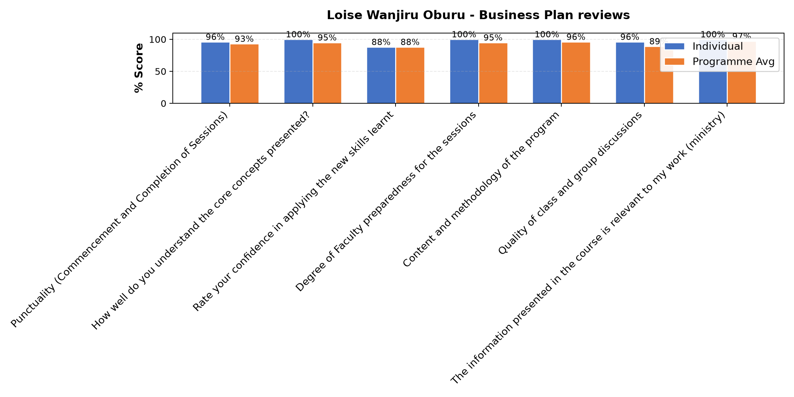

Comments & Feedback
- • Lack of frequent meetings to review our enterprise
- • No. Have taken the Challenge and ready to implement.
- • The lack of being present in the project physically
- • Lack of sufficient funds

Loise Wanjiru Oburu - Customers and competitor evaluation/Market potential evaluation/Customers, competitors and market planning
Evaluation Parameter | (%) Individual Score | (%) Programme Average
Punctuality (Commencement and Completion of Sessions) | 96 | 93
How well do you understand the core concepts presented? | 94 | 95
Rate your confidence in applying the new skills learnt | 86 | 88
Degree of Faculty preparedness for the sessions | 96 | 95
Content and methodology of the program | 96 | 96
Quality of class and group discussions | 91 | 89
The information presented in the course is relevant to my work (ministry) | 92 | 97
Average scores | 93 | 93

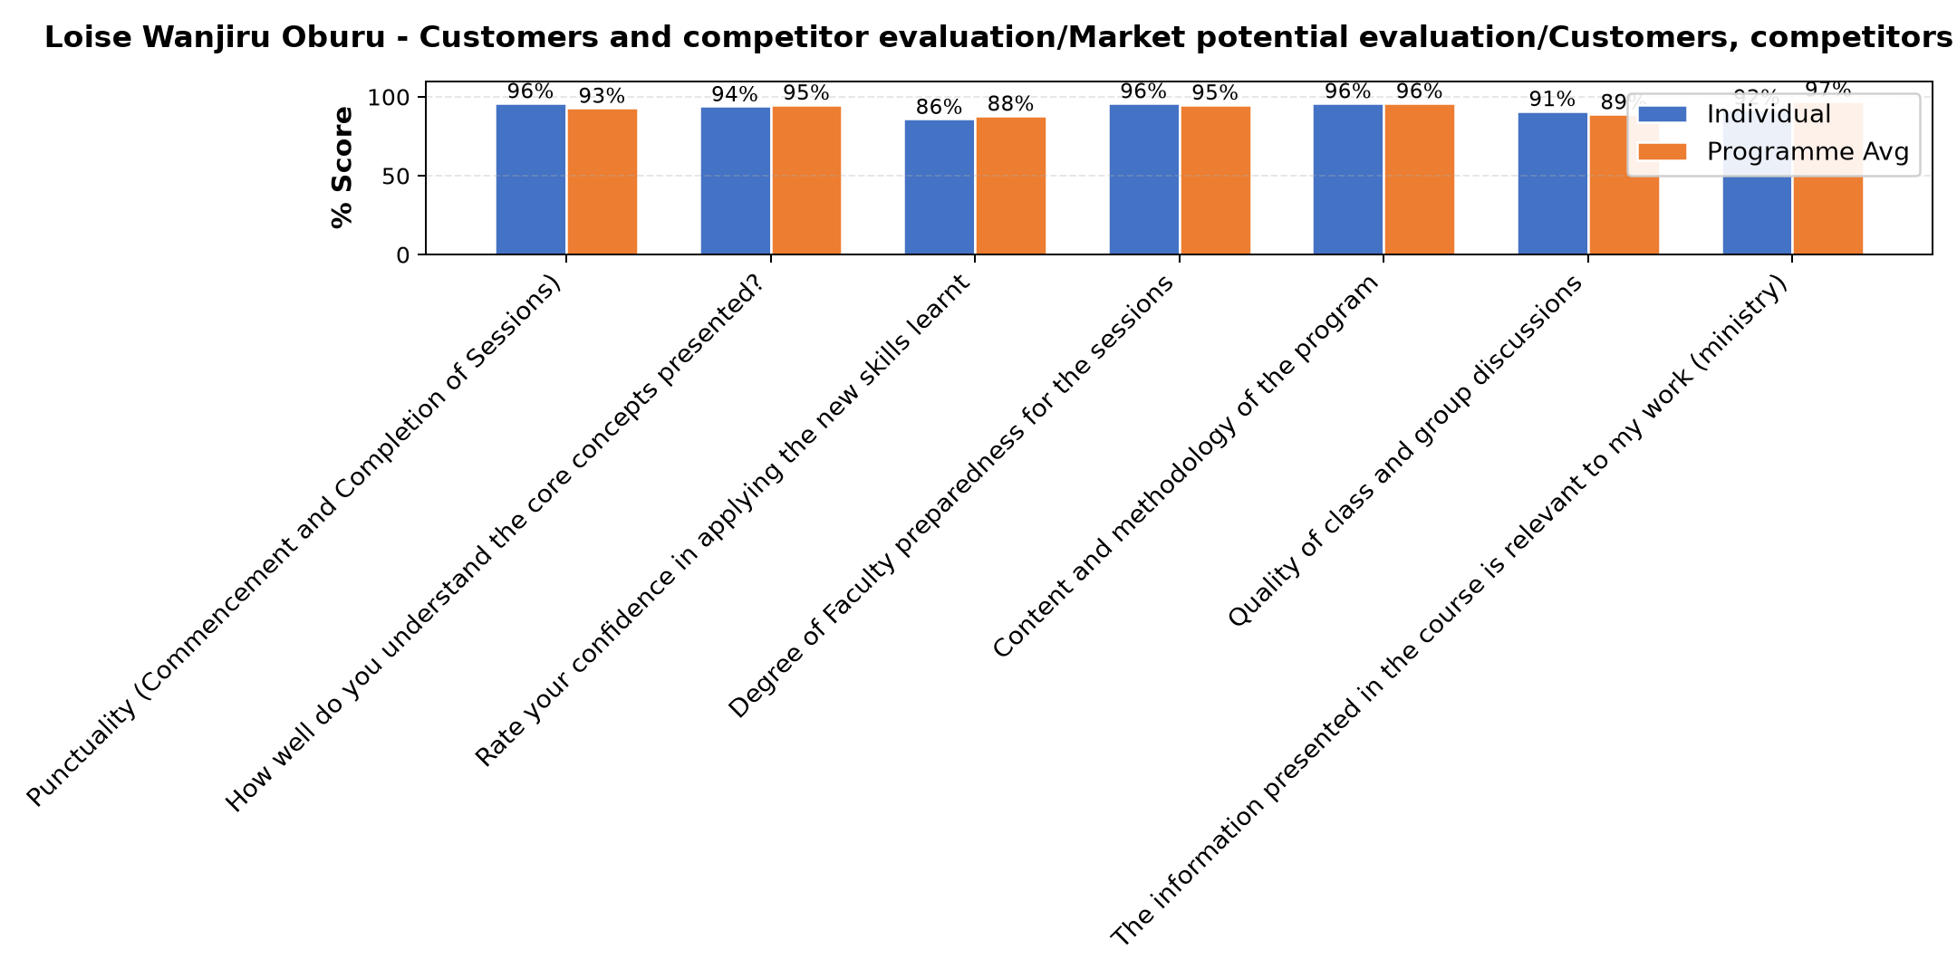

Comments & Feedback
- • May be the distance but I will make the effort to go for benchmarking
- • Ignorance
- • Internal administration challenges related to the project.
- • No barriers. What I have learnt is practical.
- • Lack of knowledge and skills
- • Delays in payment might prevent me from accomplishing the set targets on time and meet the objectives or goals ahead.
- • Ignorance of not exploring much more on our social enterprise

Dr. Cathy Mbidde - Reflect on Vision and Mission
Evaluation Parameter | (%) Individual Score | (%) Programme Average
Punctuality (Commencement and Completion of Sessions) | 91 | 93
How well do you understand the core concepts presented? | 89 | 95
Rate your confidence in applying the new skills learnt | 85 | 88
Degree of Faculty preparedness for the sessions | 95 | 95
Content and methodology of the program | 94 | 96
Quality of class and group discussions | 88 | 89
The information presented in the course is relevant to my work (ministry) | 95 | 97
Average scores | 91 | 93

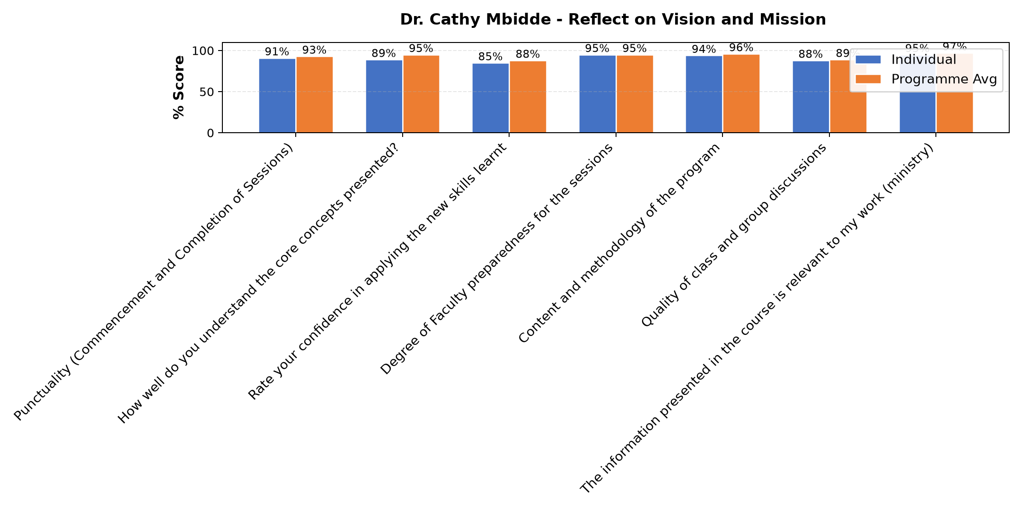

Comments & Feedback
- • Challenges in funds since the strategic plans laid as per the mission ,vision, goals and objectives for the next 3 years might fail due to delayed payments from tenants and also transfers hinders me to apply the knowledge on the project at hand hence you find that before you accomplish the task laid across for a specific period ,a new person comes in with no vision for the same project hence diverging attention or focus on other project which she is more talented in.
- • If the social enterprise is not well structured.
- • Lack of confidence to face the reality on dealing with the people in the community
- • Deeper knowledge of the core values related to the charism
- • Internal factors affecting the social enterprise including constant changes in the management
- • Finances
- • No barriers. Will do my best to apply what I learnt.
- • Lack of resources
- • Maybe If our goals and mission are not well stated If I have not internalized them.
- • Lack commitment maybe of which it won't prevent.
- • The transfers that bring new members who might take time to understand or might not be willing.

Naomi May Watetu Mwangi - Reflection and leadership and teams (employees)
Evaluation Parameter | (%) Individual Score | (%) Programme Average
Punctuality (Commencement and Completion of Sessions) | 93 | 93
How well do you understand the core concepts presented? | 97 | 95
Rate your confidence in applying the new skills learnt | 93 | 88
Degree of Faculty preparedness for the sessions | 93 | 95
Content and methodology of the program | 97 | 96
Quality of class and group discussions | 90 | 89
The information presented in the course is relevant to my work (ministry) | 100 | 97
Average scores | 95 | 93

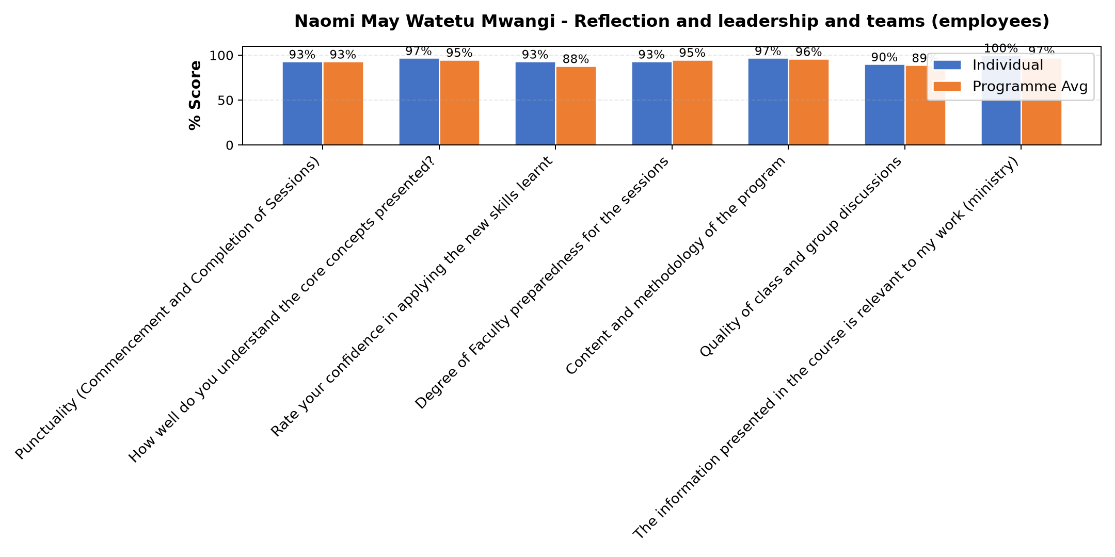

Comments & Feedback
- • Mitigation of personality and balancing differences of our ideologies in effective communication
- • Failure to understand my colour and my team members on the same. If there is no moderation.
- • No barrier will prevent me from applying what I have learnt today because I have discovered that it is necessary to know deeply even about the red personality who seems to too direct not following structures but learn to accommodate her in her weaknesses because no single colour is perfect,I have also learnt that delegation of authority does not mean that I should be asked or consulted every hour but give freedom
- • If I don't understand my color energy and that of my team members. In all I need moderation and personality awaness.

Dr. Isaac Muiruri Gachanja - Reflection of SEP Learning
Evaluation Parameter | (%) Individual Score | (%) Programme Average
Punctuality (Commencement and Completion of Sessions) | 90 | 93
How well do you understand the core concepts presented? | 97 | 95
Rate your confidence in applying the new skills learnt | 87 | 88
Degree of Faculty preparedness for the sessions | 93 | 95
Content and methodology of the program | 93 | 96
Quality of class and group discussions | 80 | 89
The information presented in the course is relevant to my work (ministry) | 97 | 97
Average scores | 91 | 93

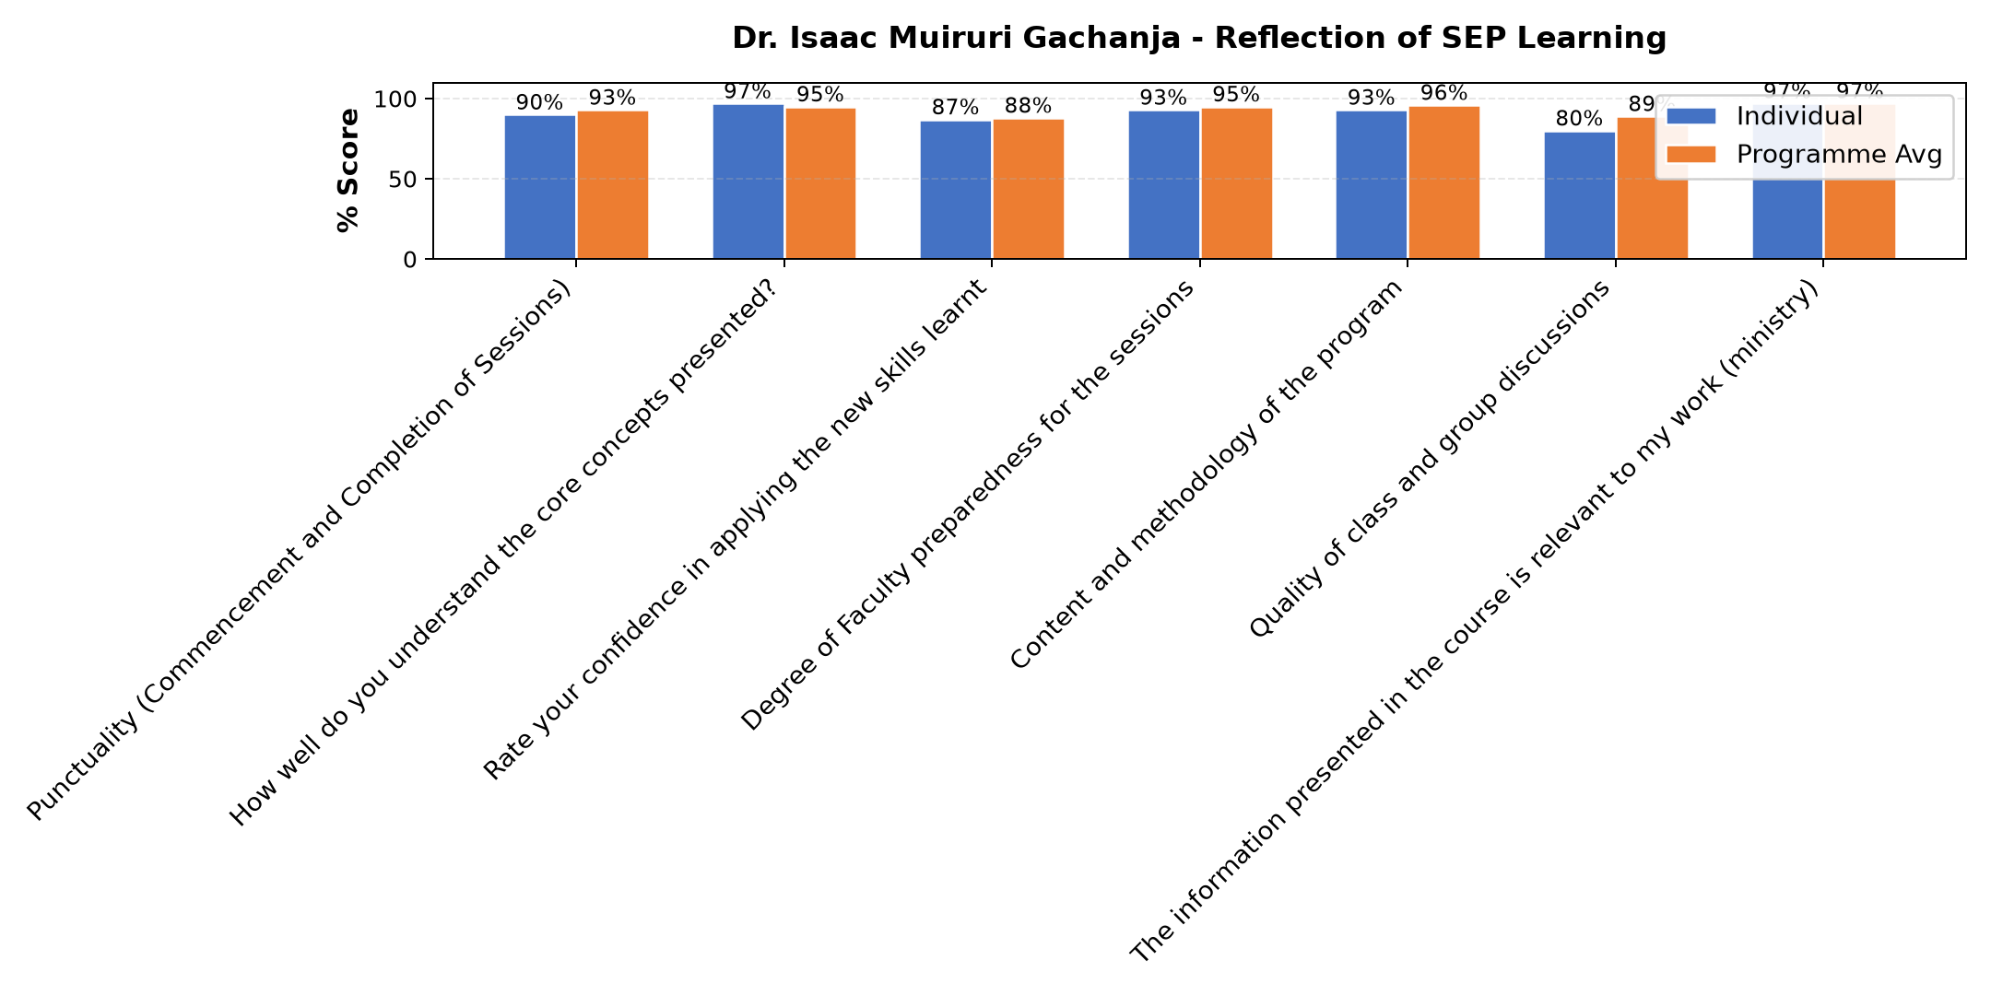

Comments & Feedback
- • Finances
- • Limited capital to expand services. Without financial resources, good plans may remain theoretical. But we thank God for the far we are.
- • So far I have tried to apply what I learnt. But at time we face different challenges in the enterprise which I look at them not really as barrier but stepping stones to achieve our goals and fullfil our mission with vision.
- • In the field of entrepreneurship what might hinder me from applying skills I have applied is Incase I will be transfered before I finalize the strategic plans,goals and objectives put across to actualize the plans ahead but if I continue the way things are currently,with new skills I am learning I will probably implement and see to it that the charism of the sisters of Mary of kakamega is aligned with the objectives and results obtained to make sure that the girl child is secure and progressing well in education sector living in comfortable atmosphere.
- • An extra mile to be initiated to help mitigate the challenges.
- • The skills gained from session has equipped us with practical knowledge on how to run a social enterprise not only as a charitable service but as a sustainable and impact-driven social enterprise. God bless Strathmore, ACWECA and all the faculties for the effort of making us realize that sustainability can be achieved even from compassionate services
- • I thank Strathmore university with the help of Hilton foundation for sensitization and close follow ups in our social enterprises to make sure that the businesses which we began are ongoing and progressing well.

Department Reports

Are there any other comments and/or suggestions that you may want to add?

Comments & Feedback
- • Next time we try to have the training during holiday time so that we can participate fully.
- • May God bless your commitments as Strathmore fraternity

General Comments

Comments & Feedback
- • I thank the facilitator for taking us through vision,mission,core values and objectives or goals which will guide me to achieve the dreams ahead ,for instance as a congregation we have a dream of putting up more accomodation rooms to mitigate challenges of girl child and soon or later we shall implement the strategy of goals and objectives with proper plans for the next 5 years and also come up with timeline in order to foster devotion and attain the goals.
- • The facilitation is lit.
- • Good work presented to us by the faculty and thumbs-up to Strathmore University for the opportunity.
- • Need more lessons to instill confidence in us as social entrepreneurs
- • This was a very well reflected recap sessions on mission, values and objectives. Helped me to separate congressional values and social enterprise values. Thanks for the choice of the presenter.
- • Thanks for organizing this it's very helpful
- • The course was good though I lost track because of power failure in our town today around 11 am
- • Great day.
- • Recommendable job
- • I really thank Dr Cathy for enlightening us on how to come up with mission, vision inline with our charism
- • The teachers were well selected. They have the mastery of the content
- • Thanks for the insightful information and especially on competitors.
- • Thanks very alot
- • The session was live & vibrant.
- • This was very well reflected and challenging session. We were invited to introspect our commitment to the projects we represent and become true agents of change given the level of trust entrusted to us. We need to be true vision carriers.
- • More sessions for this topic.
- • I've learnt that competitors in our enterprises are always there as an eye opener to grow and learn new ways of marketing and sustainable enterprises.
- • Credible work
- • We are grateful for the input God bless Strathmore fraternity.
- • Very enriching session. Am grateful
- • Am grateful for the insights and encouragements. Be blessed
- • Thanks for everything
- • I should learn to work within scheduled time and have time to rest not continue until Sunday afternoons when I should be free

Overall Evaluation
Evaluation Parameter | (%) Score
Overall program evaluation | 96
Average score | 96

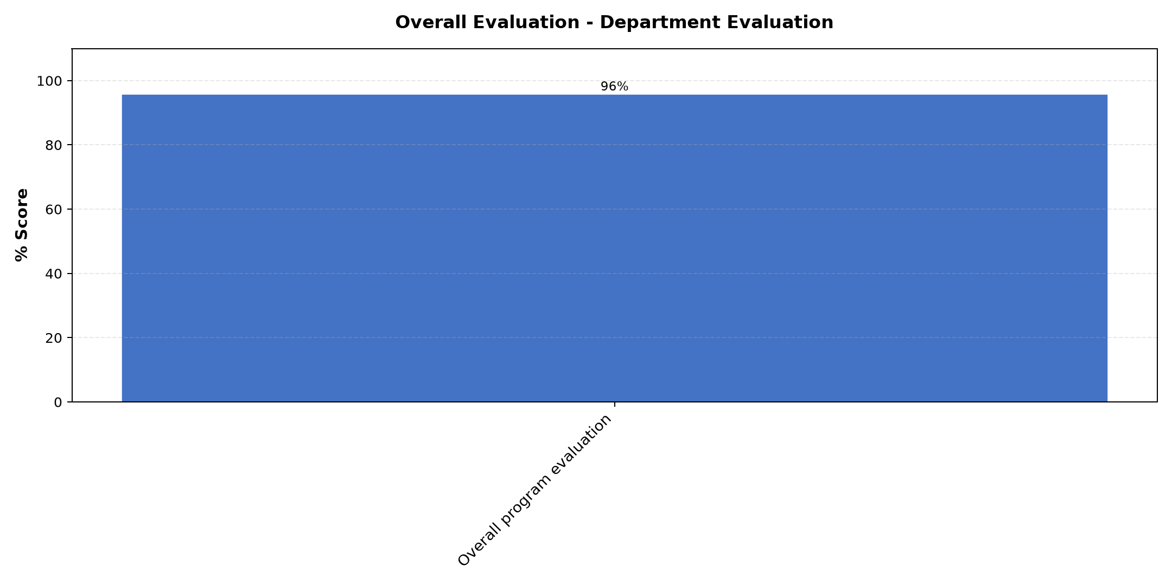

Comments & Feedback
No comments recorded.

Program Manager (Sr. Felister Kizia)
Evaluation Parameter | (%) Score
Punctuality in sending materials and programme information | 92
Communication skills(verbal and written) | 96
Response to programme enquiries via email, whatsapp and calls | 96
Accessibility and willingness to support when needed | 96
Quality of service / professionalism | 96
Average score | 95

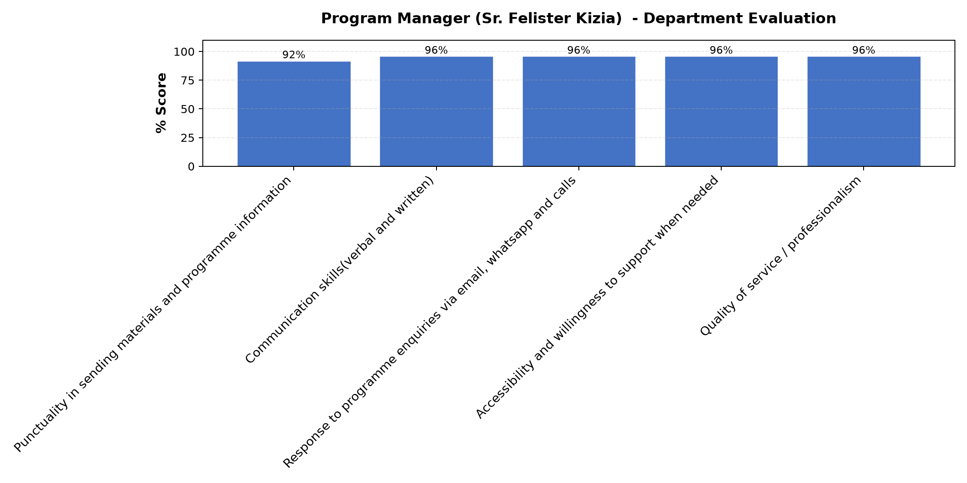

Comments & Feedback
- • The program was very insightful and practical. It has helped me understand how to manage an enterprise, identify opportunities, solve challenges, and ensure sustainability while creating positive impact in the community. It is not about being in a comfort zone but needs commitment and consistency in growth. Also, I've learnt that competitors we have in our social enterprises shouldn't be a threat but an eye opener to know more ways of marketing and achieving the goal of the facility. God bless you so much.
- • The for the support.
- • Continue journeying with the sisters. Blessings

What attracted you to the programme??

Comments & Feedback
- • Good guidance by the Faculties was so amazing that I felt a strong collaboration and support by the Strathmore team.
- • The zeal for the future of our social enterprises
- • The assurance that I will learn something new
- • The practicality of the faculties
- • To learn more on how to run all social entrepreneurship

What topic would you recommend being expanded/improved in this programme’s units?

Comments & Feedback
- • Ways Collaboration with other facilities or enterprises for better growth
- • Business plan/ marketing
- • Book keeping
- • All topics need more time but the university can choose what is viable for us.
- • Business plan review

Which areas in this programme did you find most important to your social enterprise?

Comments & Feedback
- • The business plan review and continuous evaluation of an enterprise
- • Review of the business plan.
- • Business pitching
- • All programs
- • All of them were impactful

Which teaching methods applied in the course did you enjoy/learn from the most?

Comments & Feedback
- • Presenting on our enterprise progress and guidelines on how to improve and grow to a sustainable enterprise
- • Sharing of our experiences in our various social enterprises
- • Lectures and exercises
- • All of them.

